Static Analysis Report Sprint 4
Team W

Tool used : We used SonarQube(SonarLint Visual Studio Code Extension)

We run Sonarlint in the existing codebase and identified several issues related to code smells

Bug 1 :
File : mealPlanService.js

Issue : Using an Array for frequent membership checks can reduce performance and makes the intent less clear. A Set provides faster lookup (constant time complexity) and better expresses the idea of a collection of unique allowed values.
Before : const allowedFields = ['dayOfWeek', 'mealType'];
Fix(after) :
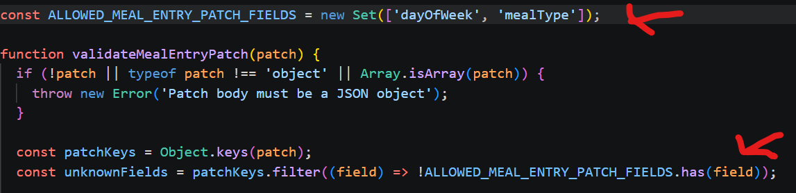

Bug 2 :
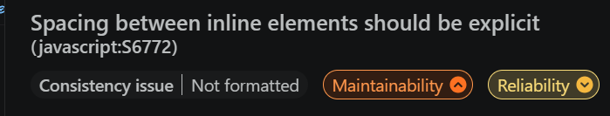
File : Preferencepage
Issue : SonarLint detected that spacing between inline JSX elements was not explicitly defined, which can lead to inconsistent rendering or readability issues.
Before :
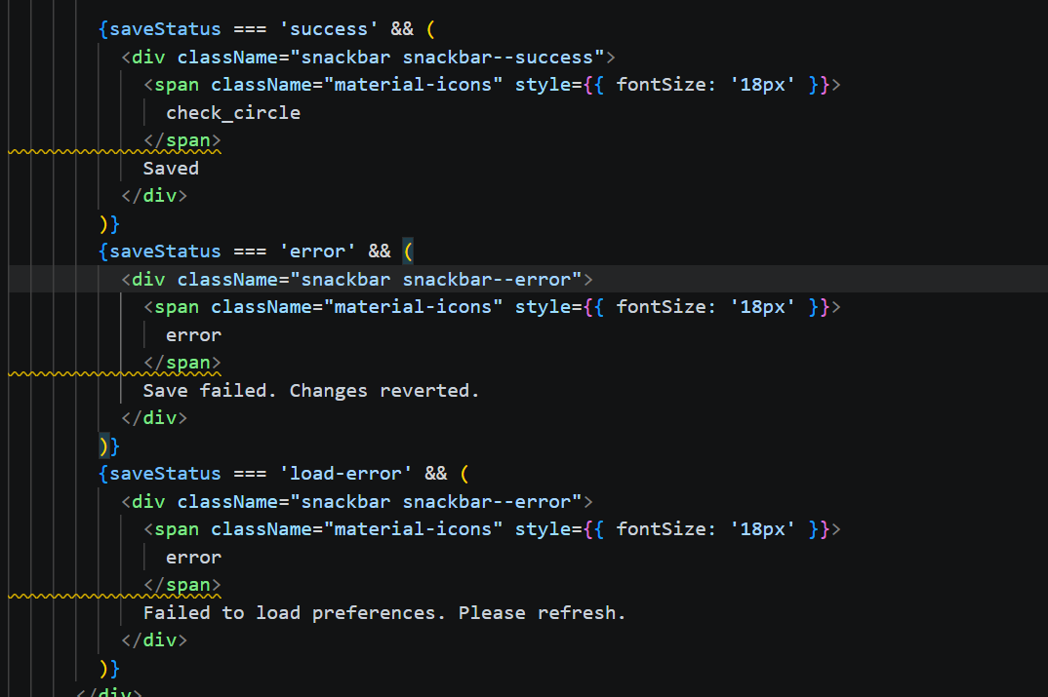

After :
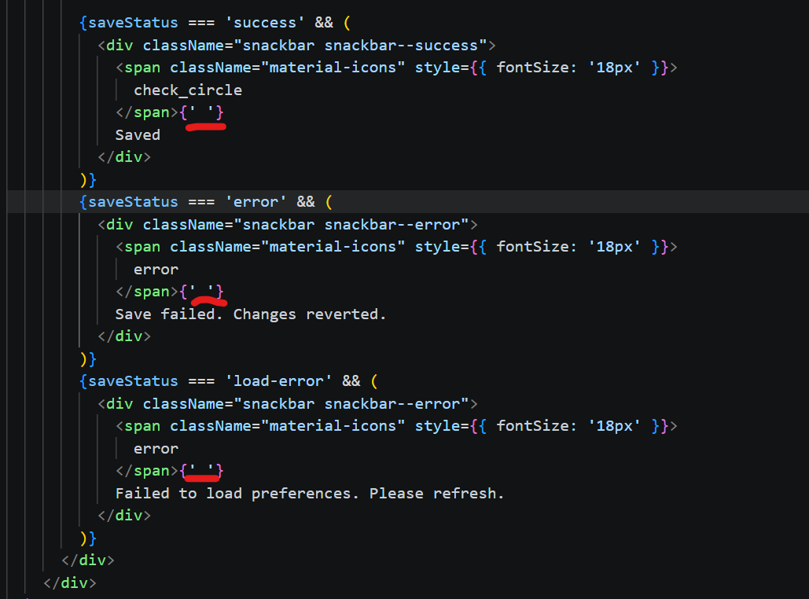

Bug 3 :
Issues :
The static analysis tool detected inconsistent boolean logic in the calculation of activeFilterCount. The condition was using negated checks (!== 'none', !== '') which can be simplified for better readability and consistency.

File : RecipesPage.jsx
Before :
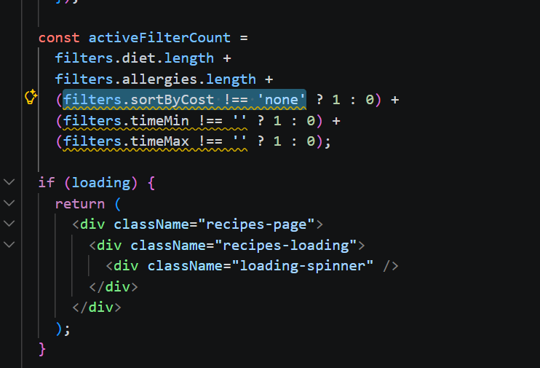

After :
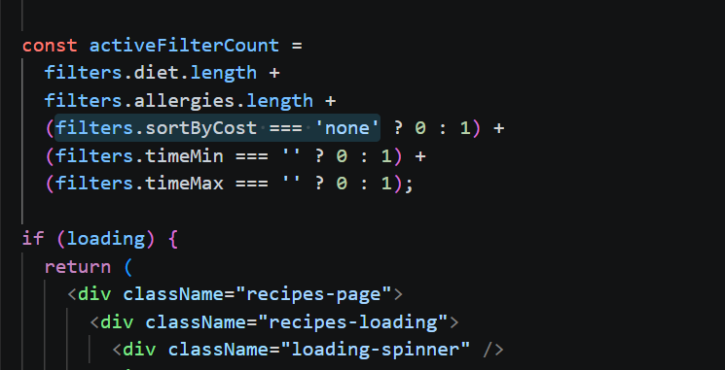
Bug 4 :
Issue :
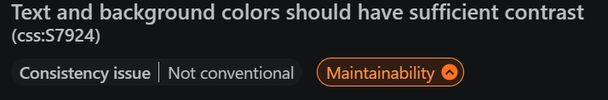
The static analysis tool detected a styling inconsistency in the CSS where hard-coded color values were modified in a single component rule, leading to potential inconsistency in the design system.
File : week-planner.css
Before :
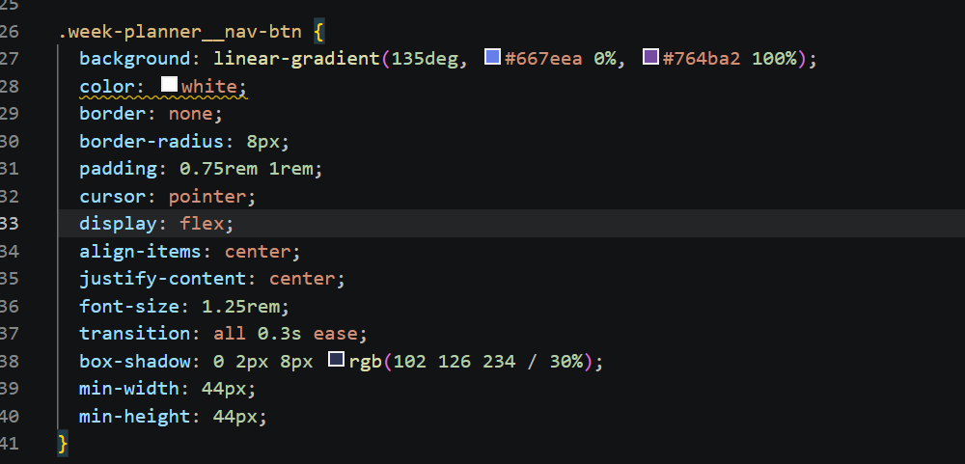

After : 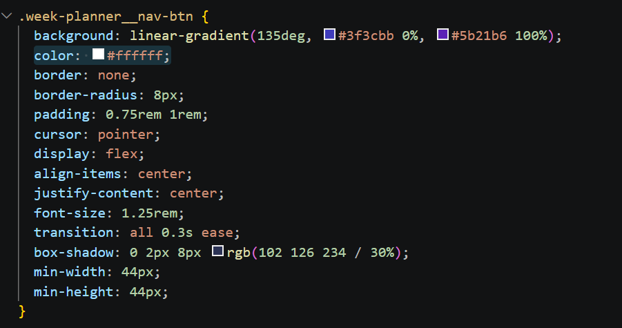
Bug 5 :
Issue :
The static analysis tool detected that React component props were not properly validated. This can lead to unexpected runtime errors and reduces code robustness.
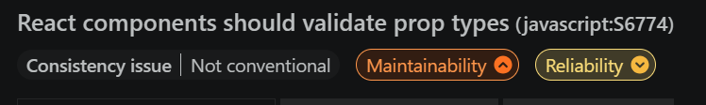
File: RecipeContext.jsx
Before :
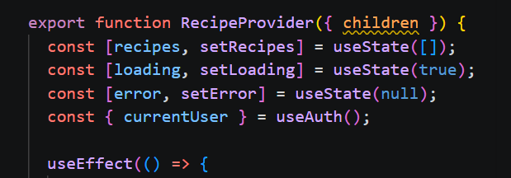
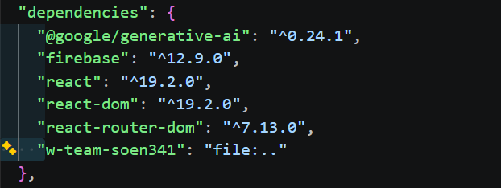

After :
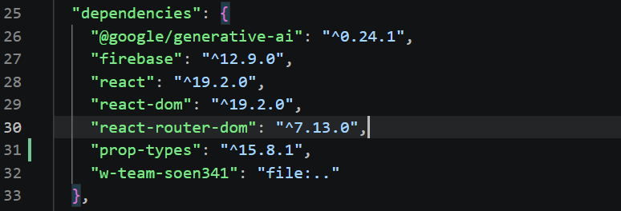
We added the propType library to validate that the children prop passed to the RecipeProvider

